**India blog**

1. **Maharashtra:**

**History:**

The name Maharashtra is believed to be originated from rathi, which means chariot driver. Maharashtra entered the recorded history in the 2nd century BC, with the construction of its first Buddhist caves. The name, Maharashtra first appeared in a 7th century in the account of a contemporary Chinese traveler, Huan Tsang. According to the recorded History, the first Hindu King ruled the state during 6th century, based in Badami.  
  
Shivaji Bhosle, the founder of the Maratha Empire, did a lifelong struggle against the Mughals. By 1680, the year of Shivaji's death, nearly the whole of Deccan belonged to his empire. Shivaji was a great warrior and one of the finest rulers of India, so he holds the highest place in Maratha history.  
  
Sambhaji succeeded Shivaji, but he is not great as his father Shivaji. 1680 to 1707 is known as the period of instability in the history of Maharashtra. Balaji Vishwanath (1712-1721), Bajirao Peshwa (1721-1740), Nanasaheb Peshwa (1740-1761), 'Thorale' Madhaorao Peshwa (1761-1772, Narayanrao Peshwa (1772-1773), 'Sawai' Madhaorao Peshwa (1774-1795) and 'Second' Bajirao Peshwa - 1795 to 1802 were the other important rulers of Maharashtra.  
  
The fall of Ahmednagar fort in 1803 marked the end of Indian rule and supremacy of British in Deccan. In 1804, General Wellesly proclaimed the Deccan in a state of chaos, established military rule and the Peshwas remained rulers for namesake.  
  
The present state was formed in 1960 with Bombay as the capital, when the Marathi and Gujarati linguistic areas of former Bombay state were separated. Maharashtra became the main channel of cultural exchange between southern to northern India.

**Tourist spots in Maharashtra:**

1. Mumbai

Mumbai is the capital city of the Indian state of Maharashtra. About 149 k from Pune, it is the wealthiest city in India with highest number of billionaires and is also one of the best include places.Mumbai is more affectionately known as the city of dreams. The city is a collection of 7 islands and was named after the goddess Mumbadevi. [Gateway of India](https://www.trawell.in/maharashtra/mumbai/mumbai/gateway-of-india), Chhatrapati Shivaji Terminus (Victoria Terminus), Elephanta Caves, Kanheri Caves, Haji Ali Darga, Siddivinayaka Temple, Juhu Beach, Marve Beach, Marine Drive, Chowpatty, Film City, Mani Bhavan Gandhi Sangrahalaya, Babulnath Temple and Mount Mary Church are some of the popular places to visit in Mumbai as part of [Mumbai tour packages](https://www.trawell.in/tour-packages/mumbai).  
  
Mumbai is the entertainment capital as well as financial powerhouse of India.

1. Ajanta Caves:

Ajanta Caves are one of the oldest UNESCO World Heritage Sites in India and also one of the top attractions you must include in [Maharashtra Packages](https://www.trawell.in/tour-packages/maharashtra). One of the most visited ancient monuments in India, these caves are situated about 98 km from Aurangabad, 326 km from Pune, and 443 km from Mumbai.  
  
Carved between 2nd Century BC and 6th Century AD, Ajanta Caves are excavated in a horse-shoe shaped bend of rock surface nearly 76 m in height overlooking the Waghur River. The complex consists of 29 rock-cut cave monuments built during the Satavahana period and the Vakataka period. The caves at Ajanta are famous for beautiful mural paintings and sculptures that depict tales of Jatakas. The world-famous paintings at Ajanta also fall into two broad phases. The earliest is noticed in the form of fragmentary specimens in Cave 9 & 10, which are among the must-visit places.

1. Mahabalshewar:

Perched at an altitude of 1,353 m in the Western Ghats of Maharashtra, Mahabaleshwar is one of the popular hill stations in Maharashtra and among the best [places to visit near Pune](https://www.trawell.in/pune/200kms) & Mumbai. It is about 123 km from Pune, and 243 km from Mumbai.  
  
Mahabaleshwar is often referred as the queen of [hill stations in Maharashtra](https://www.trawell.in/maharashtra/hill-stations). Known for its lovely views, beautiful landscapes and pleasant weather, it boasts of many tourist attractions including Pratapgarh Fort, Venna Lake, [Mahabaleshwar Mandir](https://www.trawell.in/maharashtra/mahabaleshwar/mahabaleshwar-mandir" \t "_blank), Krishnabai Temple, [Lingamala Falls](https://www.trawell.in/maharashtra/mahabaleshwar/lingmala-waterfall" \t "_blank), and Panchgani. There are several viewpoints that are strategically located to capture the panoramic views created by the majestic Sahyadri Mountains and deep valleys. Arthur's Seat, Wilson Point, Kate's Point, Elephant .....

1. Lonavala :

Situated at an altitude of 622 m in the Sahyadri Range, Lonavala is a beautiful hill station in the Pune district of Maharashtra. It is one of the top hill stations you must include in [Maharashtra tour packages](https://www.trawell.in/tour-packages/maharashtra) and among the best tourist [places to visit near Mumbai](https://www.trawell.in/mumbai/200kms) & Pune. It is located about 67 km from Pune, and 95 km from Mumbai.  
  
Lonavala has several tourist places in the form of caves, lakes, forts and waterfalls. [Lohagad Fort](https://www.trawell.in/maharashtra/lonavala/lohagad-fort" \t "_blank), Rajmachi Point, Bhushi Dam, Kune Waterfalls, [Karla Caves](https://www.trawell.in/maharashtra/lonavala/karla-caves), Tikona Fort, Visapur Fort, Bedsa Caves and Tung Fort are some of the best places .

1. Shirdi :

At a distance of 58 km from Manmad, 82 km from Ahmednagar, 90 km from Nashik, 180 km from Pune and 258 km from Mumbai, Shirdi is a small town located in Ahmednagar district of Maharashtra. This is one of the holiest places in India and also one of the popular pilgrimage places you must include in [Maharashtra packages](https://www.trawell.in/tour-packages/maharashtra). Shirdi, also known as the Land of Sai, is famous for the shrine of Shirdi Sai Baba, which is the main attraction for the devotees who visit this holy shrine. This is also one among the best pilgrimage [places to visit near Mumbai](https://www.trawell.in/mumbai/200kms).  
  
Sai Baba, who belonged to 20th century, is known as one of the greatest saints of India. Sai Baba visited Shirdi when he was 16 years old and stayed there until his death in 1918. Sai Baba transformed this small village into a holy pilgrimage site for his devotees. Many tales of the renowned Shirdi Sai are associated with this village. His selfless .....

6. Ellora caves:An UNESCO World Heritage Site, Ellora Caves are the most visited places of [heritage in India](https://www.trawell.in/india/heritage) and among the top [Maharashtra Tourist Places](https://www.trawell.in/maharashtra/best). Situated about 28 km from Aurangabad, 253 km from Pune, and 344 km from Mumbai.  
  
The [Ellora Caves](https://www.trawell.in/maharashtra/ellora-caves" \t "_blank) is an impressive complex of Buddhist, Hindu and Jain Cave temples carved out of the vertical face of the Charanandri hills between the 6th and 10th centuries AD. The caves have a slightly less dramatic setting than those at Ajanta, but more exquisite sculptures. The cave complex comprises of 34 caves includes 12 Buddhist, 17 Hindu, and 5 Jain Caves. The central attraction at Ellora is [Kailash Temple (Cave 16)](https://www.trawell.in/maharashtra/ellora-caves/kailasa-temple-kailasanath-temple-cave-16), which is the most remarkable. Shaped by hand from a single massive rock, it is a stupendous piece .....

**7.Panchgani:**

Panchgani or Paachgani is one of the popular tourist places in Maharashtra and among the must include places in your [Maharashtra tour packages](https://www.trawell.in/tour-packages/maharashtra). Situated 104 km from Pune and 254 km from Mumbai, it is one of the top [hill stations near Pune](https://www.trawell.in/best-hill-stations-near-pune) & Mumbai.  
  
Situated at an altitude of 1334 m, Panchgani is nestled in the middle of five hills in the Sahyadri mountain ranges. The town was discovered by the British as a summer resort in the 1860s. Mahabaleshwar was the summer resort of choice for the British, but it was uninhabitable during the monsoons. [Panchgani](https://www.trawell.in/maharashtra/panchgani" \t "_blank) was developed as a retirement place for the British as it remained pleasant throughout the year. It is also said that, during Vanavasa, the Pandavas spent some time in Panchgani and the cave where they stayed in the famous Devil's Kitchen.

**8. Aurangabad:**

Aurangabad is a historical city and also the tourism capital of Maharashtra. Situated about 232 km from Pune, and 350 km from Mumbai, it is one of the top [places to visit near Pune](https://www.trawell.in/pune/200kms) and also one of the top places to experience Maharashtra tourism.  
  
Named after the Mughal emperor, Aurangzeb, Aurangabad is a tourist hub of Maharashtra. The city is surrounded by many historical monuments, including the world-famous Ajanta - [Ellora Caves](https://www.trawell.in/maharashtra/ellora-caves" \t "_blank), which are UNESCO World Heritage Sites. Daulatabad Fort, Jama Masjid, Panchakki, and the 52 gates are the important tourist attractions to visit as part of [Aurangabad tour packages](https://www.trawell.in/tour-packages/aurangabad). There are also many temples, mosques, museums, and even some gardens to explore.  
  
The city is also home to the famous [Bibi ka Maqbara](https://www.trawell.in/maharashtra/aurangabad/bibi-ka-maqbara), a beautiful ....

9.Nashik:

Nashik or Nasik is the third-largest city by population in Maharashtra. Situated about 182 km from Mumbai, and 211 km from Pune, it is one of the popular places of [pilgrimage in Maharashtra](https://www.trawell.in/maharashtra/pilgrimages), and among the famous tourist places near Mumbai, which can be visited along with your [Shirdi Trip](https://www.trawell.in/tour-packages/shirdi" \t "_blank).  
  
Situated at an altitude of 700 m, Nashik is the places where Lord Rama, along with his wife Sita and brother Lakshmana has stayed during their 14-year exile. Nashik is famous for its numerous temples constructed during the reigns of different rulers. These include the magnificent ones at Sinnar, Anjaneri, [Trimbakeshwar](https://www.trawell.in/maharashtra/nashik/trimbakeshwar-tryambakeswar" \t "_blank)and those in the city itself. Panchavati, Someshwar, Ram Kund, Muktidham Temple, Coin Museum, Pandavleni Caves are some of the must include places .

10. Ganapatiphule:Ganpatipule is a small pilgrimage & beach town on the Konkan coast of Maharashtra in India. This is one of the top [places to visit in Maharashtra](https://www.trawell.in/maharashtra/best), and can be visited as a day trip as part of [Mahabaleshwar packages](https://www.trawell.in/tour-packages/mahabaleshwar" \t "_blank). It is situated about 24 km from Ratnagiri, 307 km from Pune, and 345 km from Mumbai.  
  
Ganpatipule is mainly known for its 400 years old [Ganapati Temple](https://www.trawell.in/maharashtra/ganpatipule/swayambhu-ganapati-temple) which is the prime attraction in Ganpatipule. The idol of Ganesha is believed to be a monolith that was self-incarnated and discovered over 1600 years ago. It is one of the Ashta Ganapati Temples of India and is known as 'Paschim Dwar Devata'. The temple is at the base of a hill, and pilgrims walk around (pradakshina) the hill as a mark of respect.  
  
Besides, Ganpatipule has one of the most spectacular beaches along the Konkan Coast. .....

11. Pune:

Situated at the confluence of Mula and Mutha Rivers, Pune is one of the most popular cities in India and the second-largest city in Maharashtra. About 161 km from Mumbai, Pune is one of the must include places in [Maharashtra tour packages](https://www.trawell.in/tour-packages/maharashtra).  
  
Pune boasts of several historical monuments from the Maratha period and many places of tourist interest. [Shaniwar Wada](https://www.trawell.in/maharashtra/pune/shaniwar-wada-fort" \t "_blank), Osho Ashram, Dagdusheth Ganapathi, Pataleshwar Cave Temple, Rajiv Gandhi Zoological Park, Shinde Chhatri, Raja Dinkar Kelkar Museum, National War Museum, Bund Garden, Saras Baug, Parvati Hill, Aga Khan Palace, Rajgad Fort, and Darshan Museum are the some of the prominent attractions one must visit as part of [Pune tour packages](https://www.trawell.in/tour-packages/pune).  
  
Also, Pune is considered as the cultural capital of Maharashtra and is renowned for its cultural activities such as classical .....

12. Ratnagiri:

Ratnagiri is a port city on the Konkan coast of Maharashtra. About 308 km from Pune, and 350 km from Mumbai, Ratnagiri is one of the popular beach resorts in Maharashra that can be visited as part of [Mahabaleshwar packages](https://www.trawell.in/tour-packages/mahabaleshwar" \t "_blank).  
  
Surrounded by beautiful hills of Sahyadri ranges, Ratnagiri is one of the popular attraction not to miss in [Maharashtra tour packages](https://www.trawell.in/tour-packages/maharashtra). It offers the most diverse attractions for tourists in the form of most beautiful beaches, historical monuments, and serene temples. However, the beaches in Ratnagiri dominate all other tourist attractions. [Mandvi Beach](https://www.trawell.in/maharashtra/ratnagiri/mandavi-beach" \t "_blank), Pawas Beach, Ganeshghule Beach, Bhatye Beach, and Ganpatipule Beach are the other famous beaches you must visit as part of [Ratnagiri tour packages](https://www.trawell.in/tour-packages/ratnagiri).  
  
Apart from the beaches, .....

13. Tadoba national park:Tadoba - Andhari Tiger Reserve is the oldest and largest national park in Maharashtra. Situated about 29 km from Chandrapur, and 145 km from Nagpur, Tadoba is one of the top [wildlife sanctuaries in India](https://www.trawell.in/india/wildlife) and among the must include places in [Maharashtra tour packages](https://www.trawell.in/tour-packages/maharashtra), especially for wildlife buffs.  
  
Established in 1955, [Tadoba Natioional Park](https://www.trawell.in/maharashtra/tadoba-national-park" \t "_blank) is one of the 47 project tiger reserves in India. The total area of the tiger reserve is 1,727 Sq. km and the core area of the tiger reserve is 625.40 Sq. km. Tadoba Lake acts as a buffer between the park's forest and the extensive farmland which extends up to Irai water reservoir. This lake is a perennial water source that offers good habitat for Mugger crocodiles to thrive.  
  
The Tadoba National Park is divided into three separate forest ranges, i.e. Tadoba north range, Kolsa .....

14. Igatpuri:

Igatpuri is a beautiful hill town in Nashik district of Maharashtra. About 136 km from Mumbai, and 250 km from Pune, it is one of the top [hill stations in Maharashtra](https://www.trawell.in/maharashtra/hill-stations), and among the most popular weekend [getaways near Mumbai](https://www.trawell.in/mumbai/200kms) as well as Pune.  
  
At an altitude of 1900 feet in the Sahyadri Hills of Western Ghats, Igatpuri is a treat for the eyes as this charming hill station is adorned with beautiful temples, quaint old forts, pleasant climate, majestic mountains, and splendid scenery. This quaint hill town looks even more beautiful during monsoon season with gushing waterfalls, glittering lakes, mist, and the lush greenery. Bhatsa River Valley, Camel Valley, Tringalwadi Fort, Ghatandevi Temple, and Vaitarna Dam are some important places to visit in Igatpuri during your [Maharashtra tour](https://www.trawell.in/tour-packages/maharashtra).  
  
This hill town has gained popularity .....

15. Matheran:

Situated at an altitude of 800 m in the Western Ghats range, Matheran is one of the top monsoon destinations in Maharashtra and among popular [hill stations near Mumbai](https://www.trawell.in/best-hill-stations-near-mumbai) & Pune for a weekend trip. It is about 94 km from Mumbai, 56 km from Lonavala and 122 km from Pune. It can be visited as part of [Lonavala tour packages](https://www.trawell.in/tour-packages/lonavala" \t "_blank).  
  
[Matheran](https://www.trawell.in/maharashtra/matheran), which means 'forest on the forehead', is an eco-sensitive region declared by the Ministry of Environment and Forest, Government of India. It is Asia's only automobile-free hill station. Matheran is famous for its 38 viewpoints, which provide panoramic views of the Western Ghats. Porcupine Point, Panorama Point, Echo Point, Charlott Lake, King George Point, [Louisa Point](https://www.trawell.in/maharashtra/matheran/louisa-point), Monkey Point, Paymaster Park, Panthers' Caves, Rambaug Point, .....

Famous Food in Maharashtra:

**1.**[Kaju Kothimbir Vadi](https://food.ndtv.com/recipe-kaju-kothimbir-vadi-405067" \t "_blank)

A classic Maharashtrian snack made of [gram flour](https://food.ndtv.com/ingredient/gram-flour-59), spices and an addition of cashew nuts.

### 2. [Pudachi Wadi](https://food.ndtv.com/recipe-pudachi-wadi-348222" \t "_blank)

Pudachi Wadi is a traditional preparation involving besan cases stuffed with a flavourful onion-coriander mixture infused with spices, [poppy seeds](https://food.ndtv.com/ingredient/poppy-seeds-214) and copra

### ****3.****[Batata Vada](https://food.ndtv.com/recipe-batata-vada-218327" \t "_blank)

This goes out to all the potato lovers. Batata translates into potato in English. Mashed masaledar potatoes coated in a thick besan (chickpea flour) batter and deep fried till golden. Batata vada is a street food delight tat you can easily prepare at home during the monsoon season or usually as an evening snack.

### ****4.**** [Zunka Bhakri](https://food.ndtv.com/recipe-zunka-bhakri-366242" \t "_blank)

Zunka Bhakri is traditionally made with [chickpeas](https://food.ndtv.com/ingredient/chickpeas-57) or *besan*paste which is further cooked with [onions](https://food.ndtv.com/ingredient/onion-260), [curry leaves](https://food.ndtv.com/ingredient/curry-leaves-139), ginger-garlic paste, [cumin](https://food.ndtv.com/ingredient/cumin-seeds-136) and [mustard seeds](https://food.ndtv.com/ingredient/mustard-seeds-251). Rich and aromatic, best served with bajra or jowar rotis. [*Recipe Video*](https://food.ndtv.com/video/player/ndtv-specials/zunka-bhakri/259744)

### ****5.**** [Pav Bhaji](https://food.ndtv.com/recipe-pav-bhaji-227446" \t "_blank)

The traditional hit of Maharashtra, the heart-throb of India, learn to cook the classic pav bhaji in the comfort of your kitchen space**.**

**6.**[Bharleli Vangi](https://food.ndtv.com/recipe-bharleli-vangi-218246" \t "_blank)

Beautiful [aubergines](https://food.ndtv.com/ingredient/eggplant-36) are packed with the goodness of fresh coconut and tangy spices. Straight from a Maharashtrian kitchen, on to your plate! [*Recipe Video*](https://food.ndtv.com/video/player/ndtv-specials/bharleli-vangi/259750)

**7. [Puran Poli](https://food.ndtv.com/recipe-puran-poli-951645)**

Break a sweet bread! This Maharashtrian bread is a sweet delight for your taste buds. Puran Poli is specifically made during Ganesh Chaturthi and other festive occasions like Diwali, adding up to the spirit of celebration. Gram flour parcels are stuffed with a sweet mixture of *dal*, infused with [jaggery](https://food.ndtv.com/ingredient/jaggery-180" \t "_blank) and [saffron](https://food.ndtv.com/ingredient/saffron-211).

### ****8.**** [Misal Pav](https://food.ndtv.com/recipe-misal-pav-154077" \t "_blank)

Cook up potatoes in a melange of hot *masalas*, team it up with bread to create a perfect, wholesome Maharashtrian meal. Misal pav is a meal that can be had at any time of the day.

### ****1.****[Kaju Kothimbir Vadi](https://food.ndtv.com/recipe-kaju-kothimbir-vadi-405067" \t "_blank)

A classic Maharashtrian snack made of [gram flour](https://food.ndtv.com/ingredient/gram-flour-59), spices and an addition of cashew nuts.

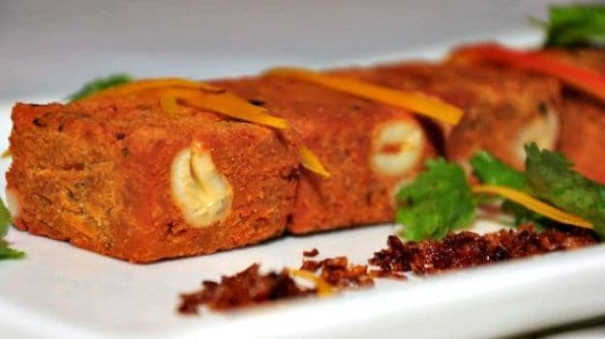

Crispy, fried snacks to acoompany a hot cup of tea.

### 2. [Pudachi Wadi](https://food.ndtv.com/recipe-pudachi-wadi-348222" \t "_blank)

Pudachi Wadi is a traditional preparation involving besan cases stuffed with a flavourful onion-coriander mixture infused with spices, [poppy seeds](https://food.ndtv.com/ingredient/poppy-seeds-214) and copra

### ****3.****[Batata Vada](https://food.ndtv.com/recipe-batata-vada-218327" \t "_blank)

This goes out to all the potato lovers. Batata translates into potato in English. Mashed masaledar potatoes coated in a thick besan (chickpea flour) batter and deep fried till golden. Batata vada is a street food delight tat you can easily prepare at home during the monsoon season or usually as an evening snack.

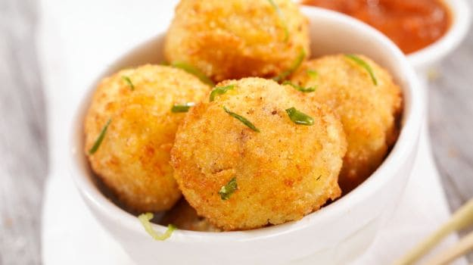

Quick and easy snack to prepare when unexpected guests arrive.

### ****4.**** [Zunka Bhakri](https://food.ndtv.com/recipe-zunka-bhakri-366242" \t "_blank)

Zunka Bhakri is traditionally made with [chickpeas](https://food.ndtv.com/ingredient/chickpeas-57) or *besan*paste which is further cooked with [onions](https://food.ndtv.com/ingredient/onion-260), [curry leaves](https://food.ndtv.com/ingredient/curry-leaves-139), ginger-garlic paste, [cumin](https://food.ndtv.com/ingredient/cumin-seeds-136) and [mustard seeds](https://food.ndtv.com/ingredient/mustard-seeds-251). Rich and aromatic, best served with bajra or jowar rotis. [*Recipe Video*](https://food.ndtv.com/video/player/ndtv-specials/zunka-bhakri/259744)

### ****5.**** [Pav Bhaji](https://food.ndtv.com/recipe-pav-bhaji-227446" \t "_blank)

The traditional hit of Maharashtra, the heart-throb of India, learn to cook the classic pav bhaji in the comfort of your kitchen space**.**

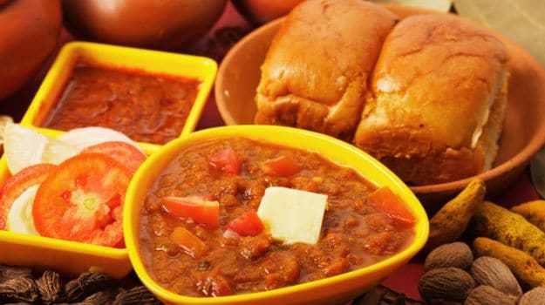

The quintessential street food, Pav bhaji is loved by kids ad adults alike.

### ****6.****[Bharleli Vangi](https://food.ndtv.com/recipe-bharleli-vangi-218246" \t "_blank)

Beautiful [aubergines](https://food.ndtv.com/ingredient/eggplant-36) are packed with the goodness of fresh coconut and tangy spices. Straight from a Maharashtrian kitchen, on to your plate! [*Recipe Video*](https://food.ndtv.com/video/player/ndtv-specials/bharleli-vangi/259750)

[**1**COMMENTS](javascript:void(0);)

### ****7.**** [Puran Poli](https://food.ndtv.com/recipe-puran-poli-951645)

Break a sweet bread! This Maharashtrian bread is a sweet delight for your taste buds. Puran Poli is specifically made during Ganesh Chaturthi and other festive occasions like Diwali, adding up to the spirit of celebration. Gram flour parcels are stuffed with a sweet mixture of *dal*, infused with [jaggery](https://food.ndtv.com/ingredient/jaggery-180" \t "_blank) and [saffron](https://food.ndtv.com/ingredient/saffron-211).

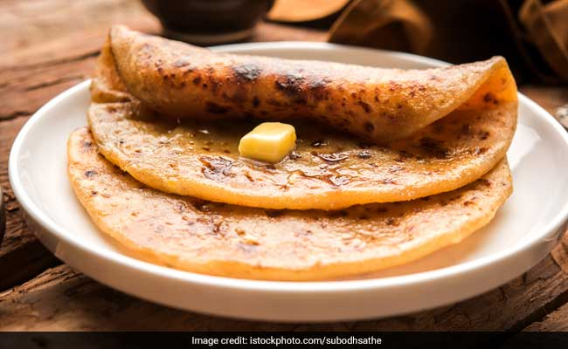In Marathi language, the sweet filling is called Puran and the outer bread is the Poli.

### ****8.**** [Misal Pav](https://food.ndtv.com/recipe-misal-pav-154077" \t "_blank)

Cook up potatoes in a melange of hot *masalas*, team it up with bread to create a perfect, wholesome Maharashtrian meal. Misal pav is a meal that can be had at any time of the day.

### ****9.****[Kolhapuri Vegetables](https://food.ndtv.com/recipe-kolhapuri-vegetables-540300" \t "_blank)

A spice Maharashtrian curry straight from the city of Kolhapur, Fresh vegetables are cooked in [yogurt](https://food.ndtv.com/ingredient/yogurt-137), ginger-garlic paste, hot spices and [lemon juice](https://food.ndtv.com/ingredient/search/lemon%20juice).

### ****10.****[Aamti](https://food.ndtv.com/recipe-aamti-467464" \t "_blank)

Cook your traditional dal the Maharashtrian way. Yellow gram dal or tuar dal is cooked with spices, curry leaves and an additional dose of special Maharashtrian goda masala

### ****11.****[Modak](https://food.ndtv.com/recipe-modak-217982) ****:**** A popular dessert from Maharashtra which is consumed highly during the festival of Ganesh Chaturthi, Modaks are now made in many parts of the country as well. Sweet flour dumplings stuffed with coconut, jaggery, nutmeg and saffron.

**Famous shopping Things:**

As enormous as the state of Maharashtra is, its shopping avenues are also exhaustive. Indeed, the state’s shopping is by no means restricted to its Paithani sarees, Kolhapuri Chappals and Himroo Shawls. In Maharashtra, each region has something interesting and unique to offer, thus while travelling in the state, one is bound to collect a surplus of souvenirs to take back home. Maharashtra offers a lucrative fusion of modern and traditional items. On the other hand, the developed cities like Pune and Mumbai have promoted mall culture in the state. However, for an authentic shopping experience in Maharashtra, it is ideal to explore the ancient bazaars in the state that are still opulent in history and variety of traditional items.

A memorable shopping experience in Maharashtra can begin from the capital city, Mumbai, where Colaba Causeway Market and its meandering lanes invite you to enjoy shopping for clothes, fruit, books, jewellery, homeware, electronic goods, you name it and it’ll be on offer here.

Other markets that are great for a wardrobe makeover in Mumbai are Linking Road and ELCO on Hill Road in Bandra (West), Vile Parle (East), Dadar, and Mangaldas Market in Bhuleshwar. The famed Crawford Market in South Mumbai offers artificial jewellery, travel bags, shoes, belts and leather goods. Apart from this, the Mohammad Ali Road arrayed with street food, and Chowpatty are your getaways for authentic food in Mumbai.

Pune also offers an eclectic meld of traditional and modern, when it comes to shopping. The city is a perfect place to buy nine-yard long Puneri Cotton Sarees along with distinct jewellery items and ready to wear tie-up sarees at ‘Kalpana.’ The sacred city of Nasik also has diverse shopping experience on offer in Maharashtra. The place is known for its brilliant craftsmanship and silverware along with diverse jewellery made of semi precious gemstones. The pooja accessories sold in Nasik are indeed one of the finest in the state.

1. **Gujarat:**

History:

May 1st marks the foundation day for the state of Gujarat. It was on this day in 1960 that the erstwhile state of Bombay was divided on linguistic basis and two states namely Gujarat and Maharashtra came into existence.

Often called ‘Jewel of Western India’, Gujarat has been on the global map since ancient times. It is said that even the Greeks knew about Gujarat.

Gujarat was officially formed in the year 1960 after the idea for the state of Gujarat surfaced in the year 1928 in a magazine called Kumar. Writer and freedom fighter K M Munshi first suggested a concept called Mahagujarat. The suggestion was made in a meeting during the Gujarat Sahitya Sabha which was held in Karachi in the year 1937. The map of Gujarat was first seen in a magazine ahead of a poem by Devshavji Parmar titled ‘Uthtrishta Jagrat’.

**Famous tourist Place in guajart:**

## [Ahmedabad Old City](http://heritage.ahmedabadcity.gov.in/)

Ahmedabad, the capital of Gujarat for many centuries, was declared to be [India's first UNESCO World Heritage City](http://whc.unesco.org/en/list/1551) in 2017, beating both Delhi and Mumbai. Its walled Old City was founded by Sultan Ahmad Shah in the 15th century and is home to diverse Hindu, Islamic and Jain communities. The Old City is divided into numerous pols (historic residential neighborhoods with winding lanes and carved wooden homes). Plus, it has some of the finest examples of Indo-Islamic architecture and Hindu Muslim art in India. Explore the area on this fascinating [Ahmedabad Heritage Walk.](https://heritagewalkahmedabad.com/)

[Gandhi's Ashram](https://gandhiashramsabarmati.org/en/) is another top attraction in Ahmedabad. It was the starting point for his movement for India's freedom through non-violence.

## 2, [Baroda (Vadodara)](https://www.gujarattourism.com/hotel/details/1014):

Baroda (renamed Vadodara) is worth visiting for its regal heritage. The [Gaekwad royal family](http://www.gaekwadsofbaroda.com/" \t "_blank) established their kingdom there in the 18th century and their expansive Laxmi Vilas Palace features imposing Indo-Saracenic architecture. It's set on 500 acres of parkland and is reputed to be the largest private residence in India—and four times the size of England's Buckingham Palace. Part of the palace is open to the public daily; this includes the Coronation Room, Gaddi Hall (containing the throne of past kings), Darbar Hall, and the Royal Armoury. Tickets cost 200 rupees and include an audio guide. [Madhav Baug Palace homestay](http://madhavbagh.com/" \t "_blank) offers an authentic heritage experience.

Baroda is also known for its art scene and vibrant [Navratri festival garba dances](https://www.tripsavvy.com/gujarati-garba-venues-for-navaratri-4136013).

* **Where:**115km southeast of Ahmedabad via the Ahmedabad Vadodara Expressway.

## 3.[Statue of Unity, Kevadia](https://statueofunity.in/" \t "_blank)

The world's tallest statue, dedicated to Indian independence activist Sardar Vallabhbhai Patel (1875–1950), was completed in 2018. At 182 meters tall, it's twice the size of the Statue of Liberty. Patel was the first Deputy Prime Minister and Home Minister of independent India, and is highly regarded for his leadership in bringing the 562 princely states of India together. The area around the statue has been developed as a comprehensive tourist destination for the whole family to enjoy, with [enough activities and attractions](https://www.soutickets.in/#/attractions) to fill in at least three days. Apart from the statue, these include a sound and laser show, butterfly garden, cactus garden, Ayurvedic wellness center, eco-friendly and medicinal plant nursery, handicraft stores, valley of flowers, forest with native trees, children's park with train and mirror maze, safari park and zoo, zip-lining, white water rafting, cycling, and boating on the lake. There's also been a heartening focus of the empowerment of local women, through training and provision of employment. Accommodations are provided in luxury tent cities, hotels and local homestays.

**04**of 18

## [Champaner-Pavagadh Archaeological Park](https://www.gujarattourism.com/destination/details/12/159)

Tilak Haria/Getty Images

VIEW MAP**ADDRESS**

Champaner, Gujarat 389360, India

**WEB** [Visit website](http://www.gujarattourism.com/destination/details/12/159)

A [little-known UNESCO World Heritage Site](https://www.tripsavvy.com/unesco-world-heritage-sites-in-india-4045879), Champaner and Pavagadh are laden with historical, architectural and archeological treasures from both Muslim and Hindu traditions, dating back to between the 8th and 14th centuries. These include a hill fortress, palaces, places of worship (Jama Masjid is one of the most spectacular mosques in Gujarat), residential areas, reservoirs and step wells.

* **Where:**An hour (48km) northeast of Vadodara.

Continue to 5 of 18 below.

**05**of 18

## [Sun Temple, Modhera](https://www.gujarattourism.com/destination/details/6/58)

Amit Basu Photography/Getty Images

VIEW MAP**ADDRESS**

GJ SH 7, Modhera, Gujarat 384212, India

The peaceful village of Modhera is home to one of the most significant sun temples in India. Built in the 11th century by Solanki dynasty rulers, it's dedicated to Surya the Sun God. The temple is a substantial structure, consisting of a carved stepped tank, assembly hall, and main shrine. It's covered in intricate stone sculptures. The sanctum is positioned in a way that it receives the first rays of the morning sun at the equinox.

* **Where:**Northern Gujarat. About two hours (99km) north of Ahmedabad.

**06**of 18

## [Rani ki Vav (the Queen's Stepwell), Patan](https://www.gujarattourism.com/destination/details/6/61)

Priyesh Balakrishnan/Getty Images

VIEW MAP**ADDRESS**

Mohan Nagar Society, Mohan Nagar Socity, Patan, Gujarat 384265, India

**WEB** [Visit website](https://www.ranikivav.com/)

Rani ki Vav is an [ancient abandoned stepwell dating back to the 11th century](https://www.tripsavvy.com/abandoned-step-wells-with-amazing-architecture-in-india-1539344) and UNESCO World Heritage Site. It was also constructed during the Solanki dynasty, apparently in memory of ruler Bhimdev I, by his widowed wife. The stepwell has stairs going down seven levels, and panels containing more than 500 main sculptures and over 1,000 minor ones. Only discovered relatively recently, the stepwell was flooded by the nearby Saraswati River and silted over until the late 1980s. When it was excavated by the Archeological Survey of India, its carvings were found in pristine condition.

* **Where:** Northern Gujarat. About three hours north of Ahmedabad (128km) and 50 minutes north of Modhera (35km).

**07**of 18

## [Idar Hill Fort, Sabarkantha District](https://www.gujarattourism.com/destination/details/6/84)

Dinodia Photo/Getty Images

Giant boulders have guarded the town of Idar, at the southern end of the Aravali mountain range, for centuries. A scenic but strenuous climb to the top of the hill (Idariyo Gadh) through the rocks will take you past the remains of various palaces and temples. The town is known for its handmade wooden toys as well. They can be purchased at the market near the clock tower.

* **Where:** Northern Gujarat. About two hours east of Patan (98km), near the Rajasthan border. It's on the way to [Mount Abu in Rajasthan](https://www.tripsavvy.com/the-top-things-to-do-in-mount-abu-4166003).

**08**of 18

## [Polo Forest, Sabarkantha District](https://www.gujarattourism.com/destination/details/12/82)

Santanu Sen/Flickr/CC BY-NC-ND 2.0

Trekkers should head to one of Gujarat's best kept secrets, Polo Forest, to discover old Hindu and Jain temples tucked away deep within the jungle. It was once a city called Abhapuri, believed to have been established in the 10th century by Idar kings and later conquered by Rathod Rajputs of Marwar in the 15th century. Visit after the monsoon, between September and December, for the most spectacular greenery.

* **Where:** Northern Gujarat. About an hour northeast of Idar (45km), near Vijaynagar. It can be reached in three and a half hours from Ahmedabad (156km).

Continue to 9 of 18 below.

**09**of 18

## [Kutch Region](https://www.tripsavvy.com/kutch-gujarat-tourism-and-travel-guide-1539325)

Manish/Getty Images

VIEW MAP**ADDRESS**

Kutch, Gujarat, India

**WEB** [Visit website](http://kutch.gujarat.gov.in/)

The immense stretch of largely barren and harsh desert landscape that is the Kutch region of Gujarat is sometimes described as India's "Wild West". Its name, Kutch (or Kachchh), refers to the fact that it alternates between wet (submerged during the [monsoon season](https://www.tripsavvy.com/monsoon-season-in-india-1539591)) and dry. Much of Kutch consists of seasonal wetlands known as the [Great Rann of Kutch](https://www.tripsavvy.com/great-rann-of-kutch-travel-guide-4134857) (famous for its salt desert) and smaller Little Rann of Kutch (famous for its [Wild Ass Sanctuary](https://www.tripsavvy.com/wild-ass-sanctuary-travel-guide-1539874)). Other attractions in the Kutch region include historic Bhuj, villages and traditional handicrafts, the ship building in the port town of Mandvi, and the Dholavira ruins of an ancient Indus Valley Civilization/Harappan city. Find out more in this [Kutch Travel Guide.](https://www.tripsavvy.com/kutch-gujarat-tourism-and-travel-guide-1539325)

* **Where:**Northwest Gujarat. Bhuj is about seven hours west of Ahmedabad (400km). It has an airport.

**10**of 18

## [Dwarka](https://www.gujarattourism.com/destination/details/12/304)

arfabita/Getty Images

VIEW MAP**ADDRESS**

Dwarka, Gujarat, India

One of the four most sacred Char Dham Hindu pilgrimage sites and seven most ancient Sapta Puri religious cities in India, Dwarka is considered to be the ancient kingdom of Lord Krishna and the first capital of Gujarat. The [Krishna Janmashtami festival](https://www.tripsavvy.com/krishna-janmashtami-govinda-festival-1539288) is a major event there. Of special importance is [Dwarkadhish Temple](http://www.dwarkadhish.org/" \t "_blank), built approximately 200 BC and often referred to as Jagat Mandir. Head down to Gomti Ghat, at the holy water's edge, for a spectacle of decorated camels, tea stalls, and seashell jewelry sellers.

* **Where:**Western Gujarat, at the mouth of the Gomti River on the Arabian Sea. It's about three hours west of Jamnagar (132km).

**11**of 18

## [Narara Marine National Park](https://www.gujarattourism.com/destination/details/5/319)

SandeepMall/Getty Images

VIEW MAP**ADDRESS**

Asha Marudi, Gujarat 361330, India

**WEB** [Visit website](https://www.gujarattourism.com/)

Isolated and off-the-beaten-track, Marine National Park lies along the coast on the way to Dwarka. It was established as a national park in 1982 and is the first of its kind in India. Yet, not many people know about it. The national park is made up of 42 islands, 33 of which are surrounded by coral reef, and is home to diverse marine and bird life. Tourists are only permitted to visit a couple of the islands though. The main one, Narara Island, is accessible by car and a long walk during low tide. Visit during the winter, and be prepared to wade through ankle deep water on the seabed. Local guides are available. Pirotan Island can be accessed by charter boat but it's difficult and permission needs to be obtained from numerous government departments in advance.

* **Where:** Western Gujarat in the Gulf of Kutch, about an hour west of Jamnagar (54km).

**12**of 18

## [Somnath](https://www.gujarattourism.com/destination/details/12/261)

Dinodia Photo/Getty Images

VIEW MAP**ADDRESS**

Somnath Mandir Rd, Veraval, Gujarat 362268, India

**PHONE** *+91 94282 14915*

**WEB** [Visit website](http://www.somnath.org/)

An important pilgrimage destination, [Somnath Temple](https://www.somnath.org/" \t "_blank) is one of the 12 jyotirlinga (shrines of Lord Shiva, where he's worshiped as a linga of light) in India. Its seaside location is powerful, the intricate carvings on its sandstone architecture are superb, and its history is fascinating. The temple was ransacked by Islamic invaders and rebuilt numerous times, with the final reconstruction taking place after India achieved independence from the British. Maha Shivratri is celebrated in a big way there in [February](https://www.tripsavvy.com/february-india-festivals-and-events-guide-1539400) or [March](https://www.tripsavvy.com/march-india-festivals-and-events-guide-1539402). A colorful religious fair is also held every year on Kartik Purnima (full moon night, usually in [November](https://www.tripsavvy.com/november-india-festivals-and-events-guide-1539300)), complete with small children dressed up as Lord Shiva and plenty of bhaang.

* **Where:** Southwest Gujarat. The closest airport is in Diu. Ahmedabad is about seven hours away. You can take a train from Ahmedabad to Veraval.
* Don't miss the evocative evening [Sound and Light Show at Somnath](https://www.tripsavvy.com/must-see-sound-and-light-shows-1539796).

Continue to 13 of 18 below.

**13**of 18

## [Gir National Park](https://www.gujarattourism.com/destination/details/5/258)

AJAY K SHAH/Getty Images

VIEW MAP**ADDRESS**

Gujarat, India

**PHONE** *+91 2877 285 540*

**WEB** [Visit website](https://forests.gujarat.gov.in/gir-nat-park.htm)

Gir National Park, one of the [top parks to see wildlife in India](https://www.tripsavvy.com/top-wildlife-sanctuaries-in-india-1539880), is the only place in the world where the Asiatic lion can now be found. Thanks to conservation efforts, their numbers have been increasing. Gir is the largest dry deciduous forest in western India. There's plenty of other wildlife there, including about 300 types of birds. You'll have the best chance of spotting a lion if you go during December through May although April and May can be very hot. Safaris run daily. Plan your trip with this [Gir travel guide](https://www.tripsavvy.com/gir-national-park-travel-guide-and-tips-1539869).

* **Where:** Southwest Gujarat, under three hours northeast of Somnath (68km). It's inland from the beaches of Diu. The closest airport is in Diu.

**14**of 18

## [Junagadh](https://junagadh.gujarat.gov.in/tourist-places)

PHOTOGRAPHS BY HIBRU/Getty Images

VIEW MAP**ADDRESS**

Junagadh, Gujarat, India

**WEB** [Visit website](http://junagadh.gujarat.gov.in/)

If you're interested in Indo-Islamic architecture, you'll marvel over the splendid design of the striking 19 century Mahabat Maqbara mausoleum complex of local rulers at Junagadh. This historical city, whose name means Old Fort, is situated at the bottom of the sacred and temple-covered Girnar Hills. On the way to the hills is a building housing 14 [rock-carved edicts of Emperor Ashoka](https://junagadh.gujarat.gov.in/tourist/ashoka-rock-edicts), dating back to 250 BC. You can also visit the ruins of Uparkot Fort, built in 319 BC by Chandragupta Maurya, which has some interesting structures such as step wells and Buddhist rock-cut caves.

* **Where:** Southwest Gujarat, about three hours south of Jamnagar (140km) and two hours north of Somnath (96km).

**15**of 18

## [Shatrunjaya Hill Temples, Palitana](https://www.gujarattourism.com/destination/details/12/215)

Tuul & Bruno Morandi\Getty Images

VIEW MAP**ADDRESS**

Shatrunjaya, Dungarpur, Gujarat 364270, India

Palitana, a principal pilgrim center for Jains, has accumulated nearly 900 temples and more are being constructed. Climb in excess of 3,000 steps to the top of the hill and you'll find an astonishing Jain temple complex with sensational views. Do note that the hill is considered to be sacred. You cannot wear or carry any leather items and must dress conservatively.

* **Where:**Southern Gujarat, about five hours south of Ahmedabad (210km). The nearest airport is in Bhavnagar, about an hour and a half away.

**16**of 18

## [Velavadar Blackbuck National Park](https://www.gujarattourism.com/destination/details/12/223)

Sylvain Cordier/Getty Images

VIEW MAP**ADDRESS**

Velavadar bhal, Velavadar, Gujarat 364313, India

**WEB** [Visit website](http://www.gujarattourism.com/destination/details/12/223)

The largest population of Blackbuck, the unusual spiral-horned Indian antelope, lives at Velavadar. This untamed area is the only tropical grassland in India to be given the status of a national park. It's home to many species of grassland birds too. The [Blackbuck Lodge](http://theblackbucklodge.com/), one of [India's top jungle lodges](https://www.tripsavvy.com/top-india-wildlife-and-jungle-lodges-1539846), is an outstanding place to stay there.

1. **Where:** About three hours south of Ahmedabad (145km) and an hour north of Bhavnagar (47km).

Continue to 17 of 18 below.

**17**of 18

## [Nalsarovar Bird Sanctuary](https://www.gujarattourism.com/destination/details/12/41)

DrRave/Getty Images

Nalsarovar Bird Sanctuary is one of the [best places to go bird watching in India](https://www.tripsavvy.com/best-bird-sanctuaries-in-india-1539881). It's made up of Nalsarovar Lake, and surrounding marsh wetlands and islands. More than 250 types of migratory birds can be seen but you'll have to go further into the lake than the standard trip to Dhrabla Island. Unfortunately, it's not set up properly for tourists. Facilities are poor and boat operators are not well regulated, resulting in them charging really high rates.

* **Where:** Just under two hours southwest of Ahmedabad (63km).

**18**of 18

## [Saputara, The Dangs](https://dangs.nic.in/tourist-places/)

Saputara, meaning "Abode of Serpents", is situated on a densely forested plateau on top of the [Sahyadri mountain range](https://www.tripsavvy.com/major-mountain-ranges-in-india-4687498). This hill station has been developed as a tourist destination with hotels around a large lake, boat club, tribal museum, cable car, artist village, and other attractions. It's a popular weekend getaway, especially during the monsoon season when it's misty there. The district, known as The Dangs, is home to a large tribal population and is an ideal place to [experience rural India.](https://www.tripsavvy.com/rural-india-tourism-ideas-1539791) Community-based tourism is being pioneered by Rura

Famous food in Gujarat:

### ****1.**** [Khandvi](https://food.ndtv.com/recipe-khandvi-98975)

One of the much-loved Gujarati snacks, *khandvi* is also known as Patuli or Dahivadi and made with gram flour. Khandvi is also a popular snack in Maharashtrian cuisine. This rolled, bright snack is tempered with [coconut](https://food.ndtv.com/health/6-ways-to-add-more-coconut-to-your-diet-695960), [mustard seeds](https://food.ndtv.com/food-drinks/why-mustard-is-good-for-you-694313) and [curry leaves](https://food.ndtv.com/opinions/curry-leaves-benefits-1246388) aand is a delight to serve with tea.  
  
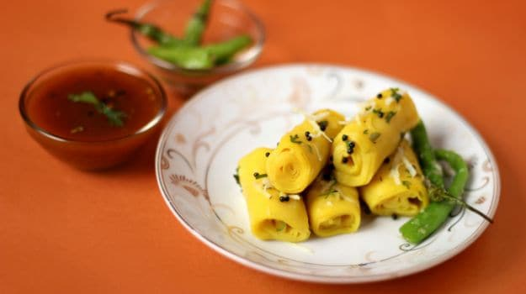A bright yellow delight, khandvi is a delicious tea-time treat.

### ****2.**** [Gujarati Samosa](https://food.ndtv.com/recipe-gujarati-samosa-219301)

This much-loved tea treat is stuffed with a chunky filling of [peas](https://food.ndtv.com/food-drinks/why-peas-are-good-for-you-693281) sauteed with [sugar](https://food.ndtv.com/food-drinks/sugar-a-guide-to-the-sweet-stuff-in-all-its-forms-694549) and [lime juice](https://food.ndtv.com/how-to/kitchen-hack-how-to-prevent-fruits-from-turning-brown-783294). A spicy, tangy snack that is hugely popular in not just Gujarat but all across the country and even beyond borders. Since you can experiment with the filling to stuff it with, we have many samosa recipes like aloo samosa to keema samosa. Perfect for evening snacks along with a hot cup of tea.

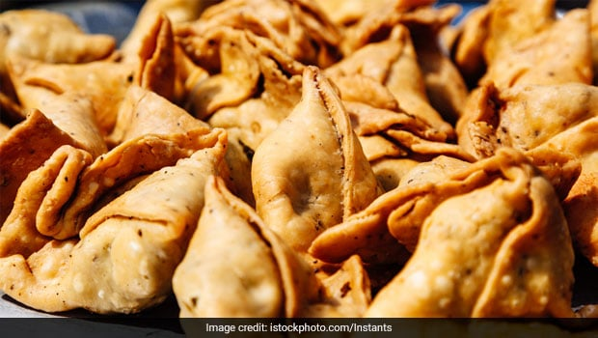Serve with a tangy sonth chutney for a enhanced flavour.

### ****3.****[Undhiyu](https://food.ndtv.com/recipe-undhiyo-548975)

This Gujarati vegetable curry is wholesome and very healthy. Made with a mélange of winter veggies like brinjals, *surti papdi*, [potatoes](https://food.ndtv.com/food-drinks/how-to-cook-perfect-sauteed-potatoes-692861), [coconut](https://food.ndtv.com/lists/10-best-coconut-recipes-776698), [bananas](https://food.ndtv.com/lists/10-best-banana-recipes-728514) and *[methi](https://food.ndtv.com/lists/10-best-methi-recipes-740827)*, this dish is traditionally served in earthen pots.

Promoted

Listen to the [latest songs](https://www.jiosaavn.com/featured/cooking-classics/3LRSE7CY4SVFo9wdEAzFBA__), only on [JioSaavn.com](https://www.jiosaavn.com/)

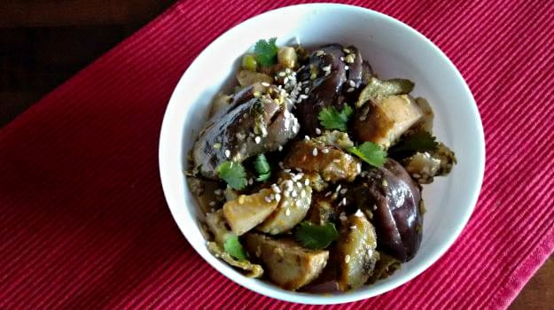  
Image credit: Plavaneeta Borah.Explore the flavours of this authentic Gujarati vegetable curry.​

### ****4.**** [Aam Shrikhand with Mango Salad](https://food.ndtv.com/recipe-aam-shrikhand-with-mango-salad-178232)

Shrikhand is a simple and soothing Gujarati dessert made with hung [curd](https://food.ndtv.com/food-drinks/how-yogurt-curd-can-help-you-keep-cool-this-summer-1397042). Mango with Shrikhand is a heavenly combination one can have in summers! Shrikhand being a creamy and luscious Indian dessert is paired with the king of fruits.

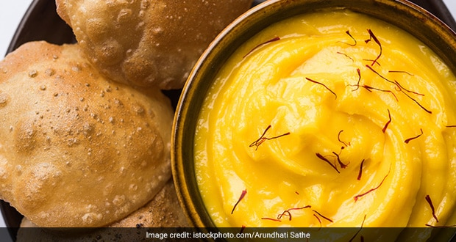Whip up some sweet comfort salad dessert with a soothing mix of yogurt, cream and mangoes.

### ****5.****[Gujarati Kadhi](https://food.ndtv.com/recipe-gujarati-kadhi-98977)

A [staple](https://food.ndtv.com/food-drinks/even-staple-food-demonstrates-nigerias-economic-vulnerability-1275842)in almost every household, Gujarati *kadhi* is a lovely [curry](https://food.ndtv.com/opinions/unravelling-the-indian-curry-693250) with sweet undertones. This cooling curry is great to escape the heat. *(*[*Recipe video*](https://food.ndtv.com/video/player/chakhle-india/gujarati-kadhi/214699)*)*

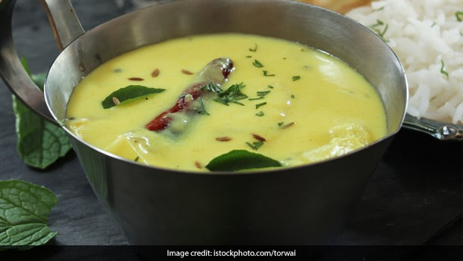Make this for lunch, paired with cooked rice and have a hearty meal on a weekend.

### ****6.**** [Dhokla](https://food.ndtv.com/recipe-steamed-dhokla-273208)

The ultimate Gujarati food, these Soft and [spongy dhoklas](https://food.ndtv.com/lists/the-best-of-gujarat-dhokla-recipe-in-6-new-avatars-695176) just cannot be missed. Dhokla is one of the most loved Gujarati snack across the country and is made in multiple ways. This dhokla recipe is a quick and easy one that is delicious as well as healthy! A recipe that is steamed and made in just 30 minutes, using besan with a colorful, chili tempering. Learn the art of making steamed dhoklas at home with this simple recipe and serve your guests along with tea. *[Dhokla Recipe Video](https://food.ndtv.com/video/player/lean-is-in/steamed-dhokla/248353)*

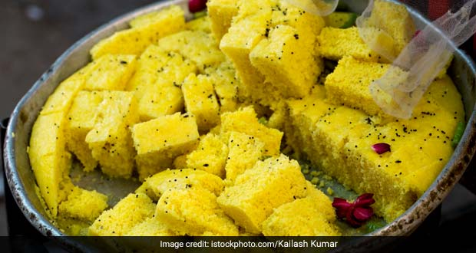You can serve dhokla along with a chutney or as is with a green chilli tempering.

### ****7.**** [Bardoli ki Khichdi](https://food.ndtv.com/recipe-bardoli-ki-khichdi-152730)

A fragrant rice preparation along with [*dal*](https://food.ndtv.com/food-drinks/cooking-with-leftovers-how-to-re-use-cooked-dal-1280901), [spices](https://food.ndtv.com/food-drinks/essential-spices-to-improve-dishs-flavour-694564), [peas](https://food.ndtv.com/food-drinks/black-eyed-peas-are-a-one-day-wonder-field-peas-are-forever-1260545), [potatoes](https://food.ndtv.com/food-drinks/new-potato-recipes-by-nigel-slater-693313) and [raw mangoes](https://food.ndtv.com/food-drinks/why-mango-is-good-for-you-693202). This is a Gujarati delight that one shouldn't miss!

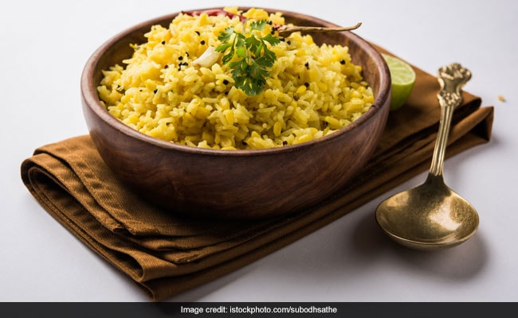Flavours of raw mango and assorted spices makes this dish a unique touch.

### ****8.**** [Methi ka Thepla](https://food.ndtv.com/recipe-methi-ka-thepla-98847)

Popularly made in Gujarat, this fine and flavorful Indian bread with made from [whole wheat flour](https://food.ndtv.com/food-drinks/wholesome-fun-how-wholemeal-flour-can-add-to-your-baking-721988) kneaded with *methi*, [chillies](https://food.ndtv.com/food-drinks/many-shades-of-red-chillies-of-india-from-sizzling-sensations-to-mild-marvels-777479), [herbs](https://food.ndtv.com/food-drinks/grow-herbs-on-your-windowsill-693122), [yogurt](https://food.ndtv.com/opinions/women-and-yogurt-whats-the-connection-693891)and a dash of sugar.

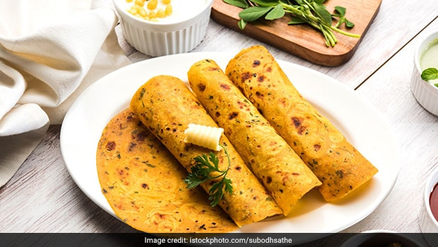A soft Indian flatbread that can be eaten in breakfast, brunch or even a full lunch meal.

### ****9.**** [Dal Dhokli](https://food.ndtv.com/recipe-dal-dhokli-492213)

A Gujarati and Rajasthani dish, Dal Dhokli is a comfort food also known as varan phal or chakolya. While it is a popular in the Marwar region of Rajasthan, it is a staple in all of Gujarat. Spiced whole wheat dumplings simmered in a lively curry made with tuvar [dal](https://food.ndtv.com/opinions/how-to-eat-dal-pakwan-the-sindhi-breakfast-of-champions-1270909), [garlic](https://food.ndtv.com/food-drinks/the-best-garlic-varieties-a-guide-694288), [peanuts](https://food.ndtv.com/health/eating-peanuts-helps-infants-avoid-allergy-even-after-pause-1284161), [kokum](https://food.ndtv.com/food-drinks/tarty-kokum-the-wonder-ingredient-that-shrinks-your-appetite-and-inhibits-weight-gain-781326)and [turmeric](https://food.ndtv.com/health/turmeric-milk-benefits-why-should-you-have-this-golden-drink-1289398).  
  
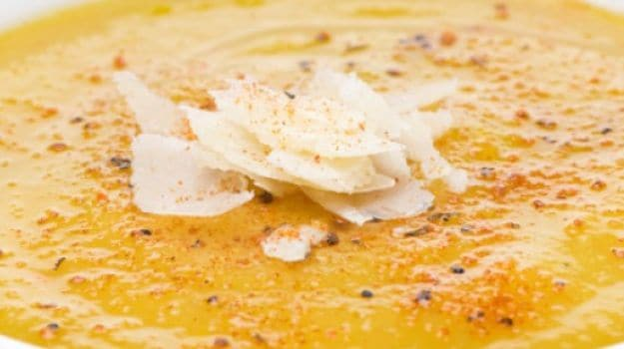  
Pair with chapati, paratha or rice for a whole meal.

### ****10.**** [Handvo](https://food.ndtv.com/recipe-handvo-466628)

A savoury tea-cake that is crisp on the outside and soft on the inside. A healthy mix of bottle gourd (lauki) along with an aromatic mix of [buttermilk](https://food.ndtv.com/food-drinks/churn-it-up-how-to-make-buttermilk-at-home-1220237), [flour](https://food.ndtv.com/food-drinks/sattu-the-healthy-flour-you-should-add-to-your-diet-1339686), [coriander](https://food.ndtv.com/food-drinks/7-amazing-coriander-seeds-benefits-from-tackling-diabetes-to-improving-the-skin-1407915), [chillies](https://food.ndtv.com/health/eat-hot-chillies-daily-to-stay-in-shape-1208859), lentils and [rice](https://food.ndtv.com/food-drinks/cooking-with-leftovers-how-to-re-use-cooked-rice-1417509). This is an easy and quick recipe made in just around 30 minutes, so you can serve this along with a chutney of your choice, to unexpected guests or even at dinner parties at home.  
  
[**1**COMMENTS](javascript:void(0);)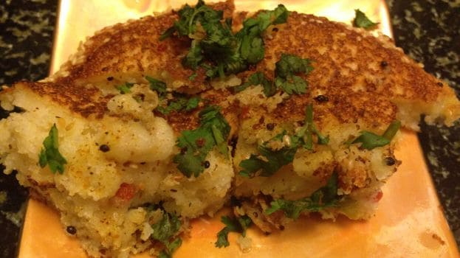Easy, quick, delicious and healthy. Handvo s the perfect gujarati snack to binge on!

### [****11. Fafda****](https://food.ndtv.com/recipe-fafda-549082)

A popular tea time snack, fafda is one of the most loved Gujarati dishes. Laced with besan and fried crisp, this is best served with a chutney of your choice and fried green chillies garnished over it. It is stuffed with spices like ajwain, haldi and salt, fafda is a quick and easy snack that you can also savour during the monsoon as well.

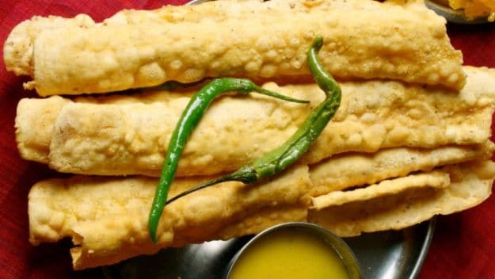In some regions, fafda is also served with Gujarati Kadhi as well.

### [****12. Patra****](https://food.ndtv.com/recipe-patra-218356)

A popular snack recipe which is a great combination of flavour and good health! Colacasia leaves are a powerhouse of nutrients like Iron and when made into a delicious dish of Patra, it is tasty as well when a smooth paste of besan with spicy, sweet and sour flavours is applied over the leaves, rolled and steamed.

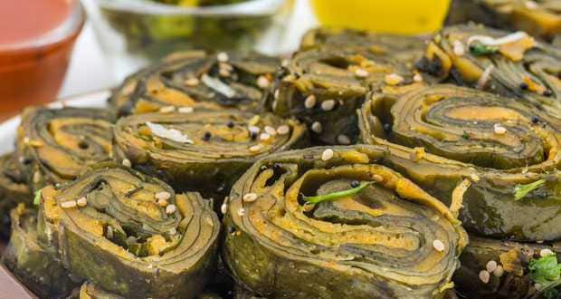A different yet delicious Gujarati snack for your next dinner party!

### [****13. Shrikhand****](https://food.ndtv.com/recipe-shrikhand-98801)

Keeping the dessert always for the last! This is one Indian dessert that you just can't afford to miss. Shrikhand is a delicacy from both Gujarat and Maharashtra, which is also known as 'Matho' and is often offered as prasad in temples during pujas and many other festive occasions. Filled with rich, creamy flavour, this recipe has delicious yogurt topped with elaichi powder. A 3 ingredient recipe, made with a few simple steps.

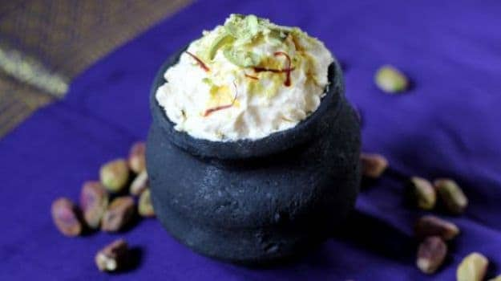

Famous shopping thing in Gujarat:

* Patola Silk Sarees
* Bandhnis and traditional Gagra-Cholis
* Embroidered, Appliquéd Quilts
* Bangles
* Khadi
* Jewelry
* Handlooms and Handicrafts

Punjab:

**History:**

The first known documentation of the word ‘Punjab’ is in the writings of Ibn Batuta, who visited the region in the fourteenth century. The term came into wider use in the second half of the sixteenth century, and was used in the book Tarikh-e-Sher Shah Suri (1580), which describes the construction of a fort by ‘Sher Khan of Punjab’.

Reference of ‘Punjab’ can also be found in volume one of “Ain-e-Akbari”, written by Abul Fazal, where ‘Punjab’ describes the territory that can be divided into provinces of Lahore and Multan. Similarly, in the second volume of Ain-e-Akbari, the title of a chapter includes the word ‘Panjnad’ in it.

However, the first mentioning of Sanskrit equivalent of ‘Punjab’ occurs in the great epic, the Mahabharata, where it is described as pancha-nada, which means ‘country of five rivers’. The Mughal King Jahangir also mentions the word Panjab in ‘Tuzk-i-Janhageeri’, derived from Persian and introduced by the Turkic conquerors of India, literally means “five” (panj) “waters” (ab), i.e., the Land of Five Rivers, referring to the five rivers which go through it. It was because of this that it was made the granary of British India.

It is one of the most ancient civilizations in the world with a distinguished culture. Punjabi language has its origins in the Indo-European family of languages which included Persian and Latin. A land of ethnic and religious diversity, it is birth place of a number of religious movements. Some of the prominent ones include Sikhism, Buddhism and many Sufi schools of Islam.  
The Indian State of Punjab was created in 1947, when the partition of India split the former Raj province of Punjab between India and Pakistan. The mostly Muslim western part of the province became Pakistan’s Punjab Province; the mostly Sikh eastern part became India’s Punjab state. The partition saw many people displaced and much intercommunal violence, as many Sikhs and Hindus lived in the west, and many Muslims lived in the east. Several small Punjabi princely states, including Patiala, also became part of Indian Punjab.

In 1950, two separate states were created; Punjab included the former Raj province of Punjab, while the princely states of Patiala, Nabha, Jind, Kapurthala, Malerkotla, Faridkot and Kalsia were combined into a new state, the Patiala and East Punjab States Union (PEPSU). Himachal Pradesh was created as a union territory from several princely states and Kangra District. In 1956, PEPSU was merged into Punjab state, and several northern districts of Punjab in the Himalayas were added to Himachal Pradesh.

Famous tourist spots in Punjab:

### 1. Amritsar

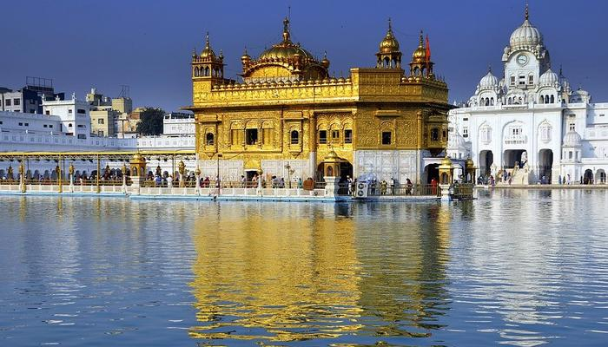

[Image Source](https://pixabay.com/en/amritsar-golden-temple-sikh-3083693/)

The city known for legends, patriotism, and spirituality, Amritsar is found listed at the top when anyone talks about the religious places to visit in Punjab. Home to the Golden Temple, or Sri Harmandir Sahib, this is among the most significant pilgrimage site for Sikhs. You will find a lot of **Punjab famous monuments**. The narrow lanes of Amritsar are arrayed with shops selling colorful juttis, suits and more. A foodie cannot have enough of Amritsari Kulche, Butter Chicken, Lassi – the list is long!

### 2. Chandigarh

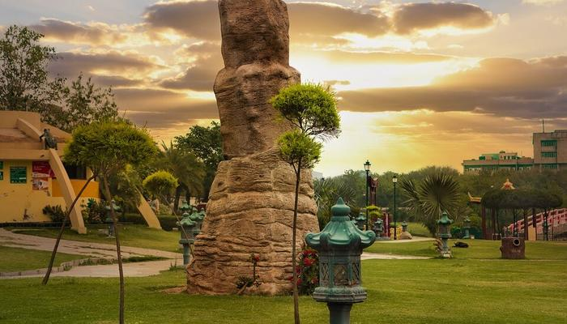

[Image Source](https://pixabay.com/en/green-trees-cloudy-nature-summer-3395714/)

The capital of Punjab, Chandigarh is counted among the metro cities of India and among the **top places to visit in Punjab**. This welcoming city will greet you with the flavors of everything between modernity and antiquity. Chandigarh also is one of the cleanest cities in the country, where one can spend time shopping in the mall, lounging at a cafe or unwinding by a lake or garden. If you’re wondering what to see in Punjab, this city has to be your answer. You wouldn’t even have to worry about how you will reach, as this city is blessed with ease of connectivity via road, rail, and even airways. If you are planning to explore **famous places in Punjab** then you must surely plan a visit to Chandigarh.

### 3. Ludhiana

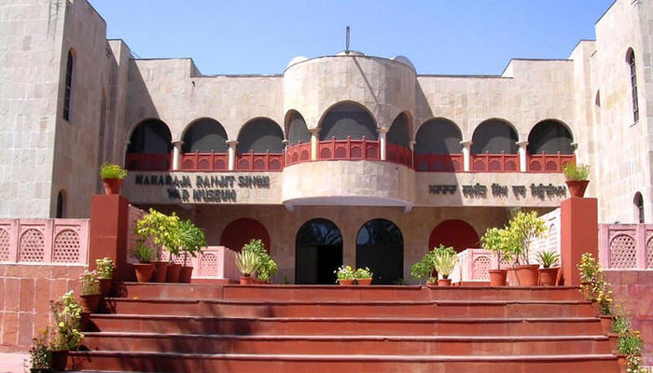

[Image Source](https://image3.mouthshut.com/images/imagesp/925739831s.jpg)

Yet another recommendation in our list of **places to see in Punjab** in Ludhiana. This is where you will be able to witness the true beauty of the state and its rich agricultural scenario. This simple yet stunning city will give you an insight into the lifestyle of locals, especially if you are ambling in the Museum of Rural Life. There’s history, a little bit of wildlife in the zoo, delicious food, and even an amusement park to look forward to if you are traveling with kids.

### 4. Jalandhar

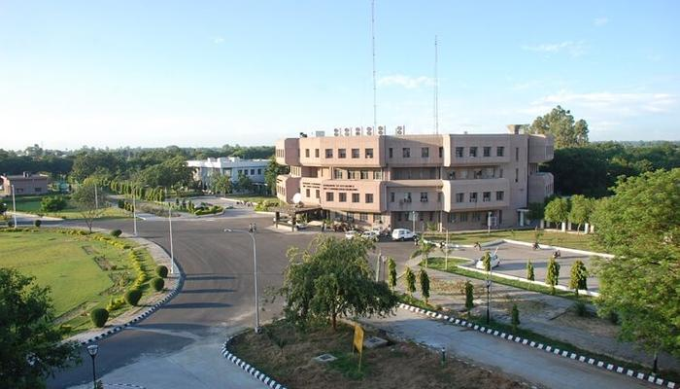

[Image Source](https://image3.mouthshut.com/images/imagesp/925739831s.jpg)

Flaunting the culture of Punjab, Jalandhar is a name that can never be forgotten in a list of best places to visit in Punjab. This is an ancient city, holding special significance for not just Sikhs but also Hindus as it is home to many holy shrines. From street shopping to popping tags in showrooms, Jalandhar has so much on offer. If you are out exploring with the kids, you will have so much in store. This is one of the most popular **cities to visit in Punjab**.

### 5. Bhatinda

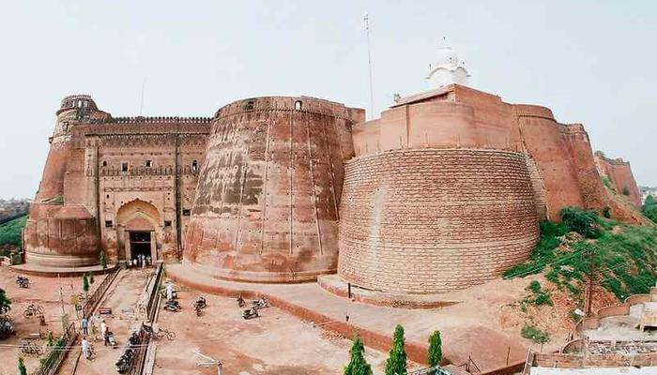

[Image Source](http://www.weekendthrill.com/wp-content/uploads/2016/07/Bhatinda-compressed.jpg)

The City of Lakes, Bhatinda is a simple city, which still is among the **tourist places in Punjab** you cannot miss. There are various landmarks in the city that have brought massive development in the state, right from AIIMS to thermal power plants and the Central University of Punjab. The city narrates legendary tales of the past as the remnants stand as witnesses. Rulers like Mahmud of Ghazni, Muhammad Ghori, and Prithvi Raj Chauhan have fought wars and ruled the city in the erstwhile era. It is one of the best **places to visit in Punjab with family**.

### 6. Patiala

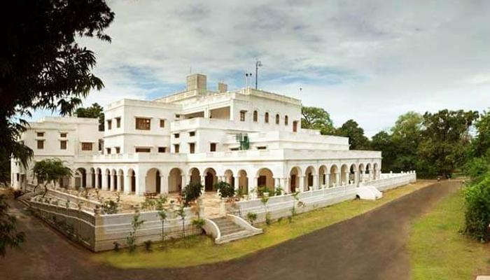

[Image Source](https://img.dainiksaveratimes.com/Uploads/img/2016/11/29/2529112016040044.jpeg)

The fourth largest city of the state, Patiala is name we see featured in list of **beautiful places in Punjab** quite often. It is also called the City of Newspapers, and the monuments here showcase a blend of different architectural styles such as Mughal, Rajput and of course Punjab. You will find a plethora of **places to visit in Patiala, Punjab**. If you are a history enthusiast, this city will not disappoint you. Patiala is also a choice for the travelers who wish to shop for authentic Punjabi items such as juttis, parandas and more.

### 7. Kapurthala

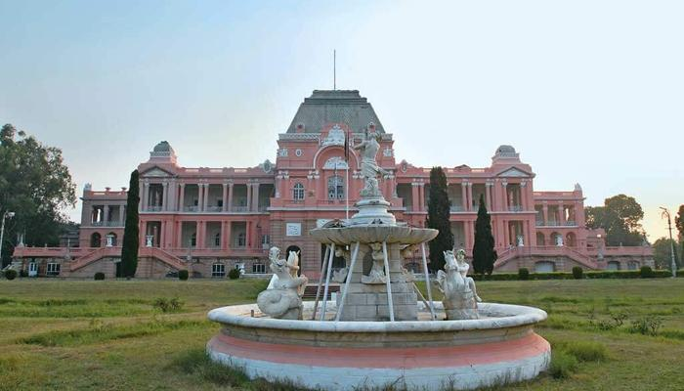

[Image Source](https://www.outlookindia.com/outlooktraveller/wp-content/uploads/2017/05/PUNJAB-AND-HARYANA6_Kapurth-1.jpg)

One of the less-known places to visit in Punjab, Kapurthala is known as the Paris of Punjab, owing to its intriguing architectural scenario. Most landmarks here are built in French and Indo-Saracen styles of architecture. There also are interesting legends you can know about during your trip to the city. For someone who wishes to explore a city with lovely architecture, Kapurthala is nothing less than a treasure! This is one of the best **tourist places in Punjab**.

### 8. Pathankot

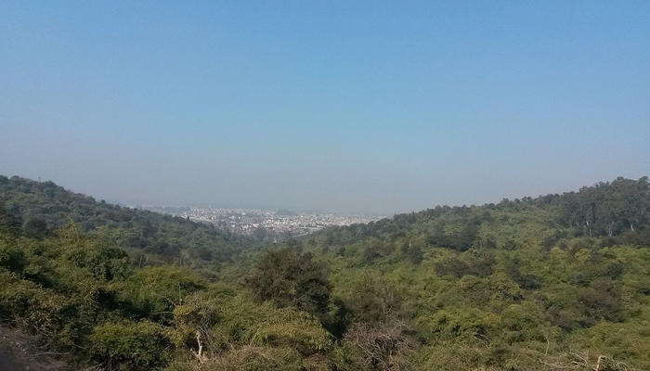

[Image Source](https://upload.wikimedia.org/wikipedia/commons/thumb/5/55/Pathankot_City.jpg/1200px-Pathankot_City.jpg)

One of the most **famous places in Punjab**, Pathankot borders with Himachal Pradesh and Jammu & Kashmir. Blessed with lush greenery, this city looks even more stunning during the monsoon season. Alongside its lovely landscape, the city is known for its history as well. Pathankot also serves as a major railhead to various neighboring cities in Himachal such as Dalhousie.

### 9. Nangal

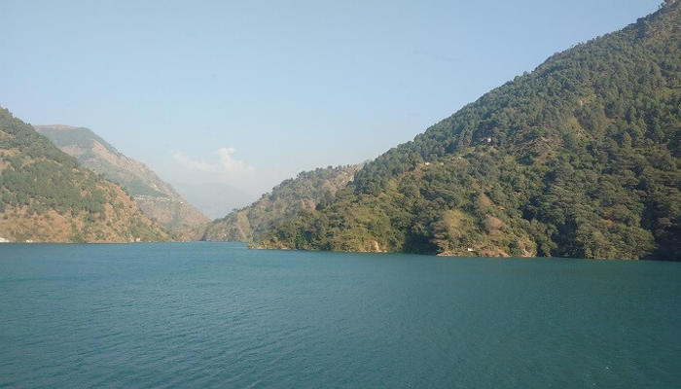

[Image Source](https://commons.wikimedia.org/wiki/File:The_heritage_of_India_-_SATLUJ_RIVER_2.jpg)

Have you ever heard of Bhakra Nangal Dam? Yep, it is right there in Roopnagar’s district of Punjab. One of the **offbeat places to visit in Punab**, Nangal is a perfect one day getaway from Chandigarh. If you are confused about whether there is anything to see in Nagal, then you will be surprised by the number of things to do here. Do not miss out having a picnic from the huge dam. Lay your eyes on beautiful Shivalik Hills from this point. Enjoy a sunny winter afternoon in Satluj Park and celebrate 500 years of Sikh history at Virasat-e-Khalsa.

### 10. Ropar

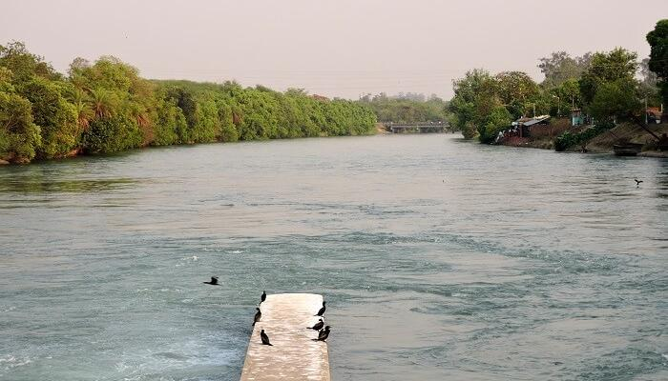

[Image Source](https://pa.wikipedia.org/wiki/%E0%A8%A4%E0%A8%B8%E0%A8%B5%E0%A9%80%E0%A8%B0:Ropar_wetland_outlet,at_Satluj_river,_Ropar,_Punjab,_India.jpg)

If you are looking for **places to visit near Jalandhar, Punjab**, Ropar is a close one. Also known as Roopnagar, Ropar is an ancient town in Punjab which is more famous for its ruin from Harrapan civilization. Didn’t expect Ropar to be of such historical importance, did you? Well, that is the thing about Punjab. It is a culturally and historically rich state of India, the glimpse of which you can find in Ropar.

### ****11. Mohali****

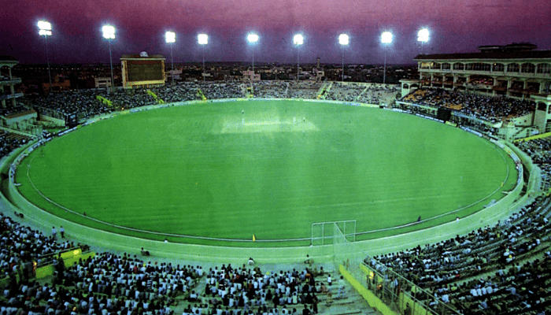  
Still looking for **best tourist place in Punjab**? Also known as Ajitgarh, Mohali is a major commercial, cultural and transportation centre. The place has a significant importance in promoting sports. As Mohali is home to PCA Cricket Stadium and International Hockey Stadium, both the stadiums lure sports enthusiasts from all across the country to this beautiful destination. The place is also visited by devotees as there are many popular Gurudwaras here including Gurudwara Amb Sahib, Singh Shaheedan, etc.

### ****12. Sirhind****

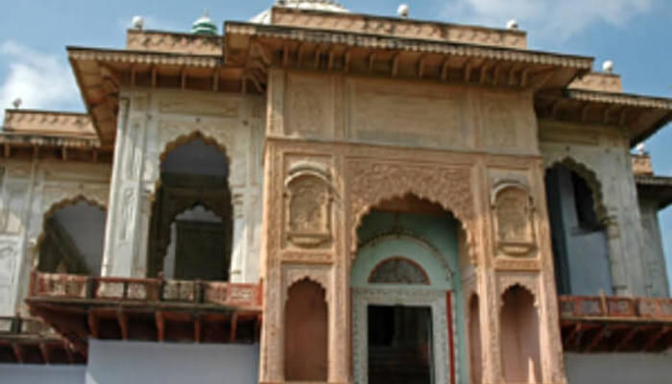

Sirhind was earlier known as Fatehgarh Sahib. It was a military outpost of Prithviraj Chauhan in his revolt against Muhammad Ghori. The place turned out to be part of Ghauri Sultanate and later in the year 1362, it was refounded by Tughlaq emperors. If you visit Sirhind, you will witness the traces of its past story giving you a perfect chance of exploring the struggles of previous kings. Currently, it is prominent pilgrimage spot for Sikhs as the two young sons of Guru Gobind Singh were brutally killed here.

Famous food in Punjab:

### ****1.****[Butter Chicken](https://food.ndtv.com/recipe-butter-chicken-106717)

Presenting, the classic butter chicken that is unknown to none. Juicy chicken pieces bathed in a creamy gravy bursting with authentic flavours.

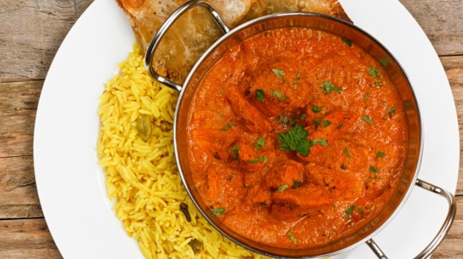Best punjabi dishes: Presenting, the classic butter chicken that is unknown to none

### ****2.****[****Sarson Ka Saag Aur Makki Ki****Roti](https://food.ndtv.com/recipe-sarson-ka-saag-aur-makki-ki-roti-218092)

Palak, bathua and sarso saag come together to create a sensation with hearty makke ki roti. Simple, savoury and full of rustic flavours.

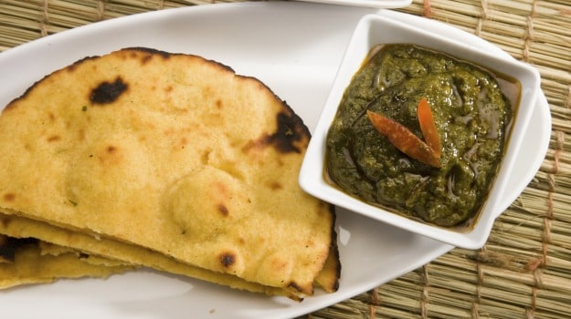Best punjabi dishes: Palak, bathua and sarso saag come together to create a sensation with hearty makke ki roti

### ****3.****[Tandoori Chicken](https://food.ndtv.com/recipe-tandoori-chicken-232839)

Hard to resist, tandoori food never fails to please one and all. Chef Aditya Bal shows you simple steps and tricks to create some tandoori magic right in the comfort of your home!

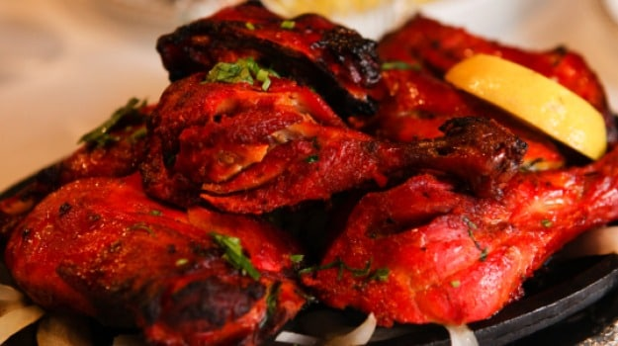Best punjabi dishes: Hard to resist, tandoori food never fails to please one and all

### ****4.****[Chole Bhature](https://food.ndtv.com/recipe-chole-bhature-231327)

Talk about Punjabi food and the popular chole bhature can never be given a skip. The dish has become one of the favourites with people across the country and is also one of the must try Indian delicacies.

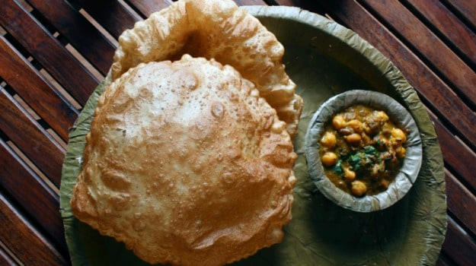Best punjabi dishes: Talk about Punjabi food and the popular chole bhature can never be given a skip

### ****5.****[Masala Channa](https://food.ndtv.com/recipe-masala-channa-346952)

Boiled chickpeas wrapped in a flavourful mix of masalas and cooked to perfection. A quick fix for an afternoon meal or a great option for a hurried weekday dinner. This recipe will be loved by one and all.

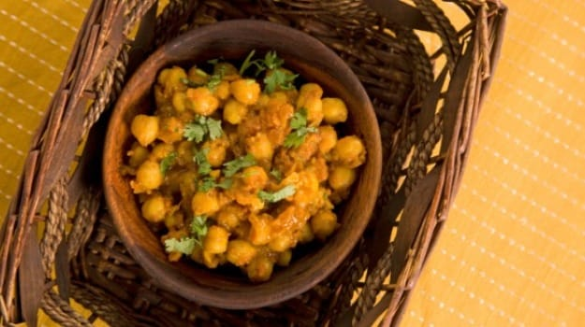Best Punjabi dishes: Boiled chickpeas wrapped in a flavourful mix of masalas and cooked to perfection

### ****6.****[Dal Makhani](https://food.ndtv.com/recipe-dal-makhani-98968)

From the local highway dhabas to some of the most sophisticated five star hotels - Dal makhni finds its dedicated space on menus across eating joints and restaurants and beyond all cultural division. Master the art of cooking the queen of all dal preparations.

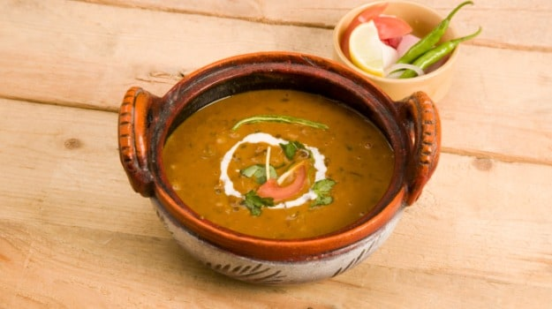Best Punjabi dishes: Dal makhni finds its dedicated space on menus across eating joints and restaurants

### ****7.****[Machchli Amritsari](https://food.ndtv.com/recipe-machchli-amritsari-218211" \t "_blank)

A treat for all fish lovers. Beautiful pieces of fish, coated in a spicy batter and deep fried to a golden perfection. Garnished with a sprinkling of [garam masala](https://food.ndtv.com/recipe-garam-masala-218599) and a dash of lemon juice for that extra zing.

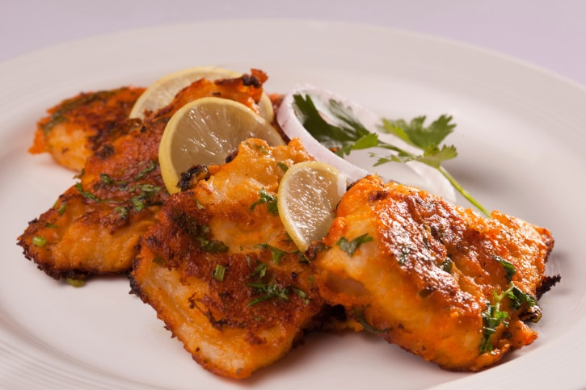Best Punjabi dishes: Beautiful pieces of fish, coated in a spicy batter and deep fried to a golden perfection

### ****8.****[Dhaba Dal](https://food.ndtv.com/recipe-dhaba-dal-168595" \t "_blank)

Wonder why the food served by those simple, roadside dhabas is so distinctly flavourful? They make the most of local spices and rustic techniques and unadulterated recipes handed over by generations. Here's an authentic recipe of dhaba dal.

* [Lists](https://food.ndtv.com/lists)
* 13 Best Punjabi Recipes | Easy Punjabi Recipes

# 13 Best Punjabi Recipes | Easy Punjabi Recipes

## 13 Best Punjabi Dishes: Find here list of 13 best Punjabi dishes (Vegetarian & Non Vegetarian) like murgh malaiwala, paneer tikka, dhaba dal, machchli Amritsari & many more with key ingredients and how to make process.

NDTV Food Desk  |  Updated: January 17, 2020 17:48 IST

[Tweeter](https://twitter.com/share?url=https%3A%2F%2Ffood.ndtv.com%2Flists%2F10-best-punjabi-recipes-724174)[facebook](https://www.facebook.com/sharer.php?u=https%3A%2F%2Ffood.ndtv.com%2Flists%2F10-best-punjabi-recipes-724174&text=13+Best+Punjabi+Recipes+%7C+Easy+Punjabi+Recipes)[Reddit](https://www.reddit.com/submit)

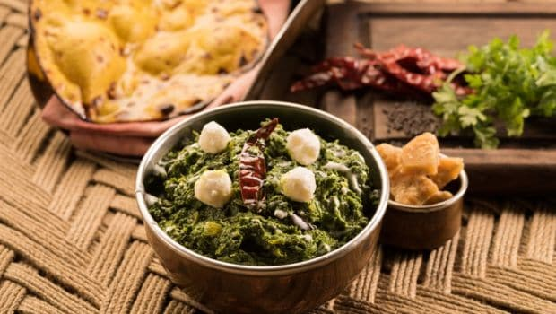**Punjabi Recipes:** One of the most impressive things about [Punjabi](https://food.ndtv.com/food-drinks/love-punjabi-food-heres-how-you-can-make-a-six-course-fun-punjabi-meal-at-home-1909350) food is its variety. While meat lovers can never have enough of the evergreen Butter Chicken, Bhuna Gosht, Tandoori Chicken and Amritsari Machchi, vegetarian fare is equally delightful. Sarson ka Saag, Chole Bhature and Dal Makhni are just a handful of vegetarian Punjabi specialities with fans across the globe. Think of Punjab and you can imagine its earthy heritage of lush green fields and robust lifestyle. What makes Punjab different from the other states is its culinary treasure, it is a state synonymous with food. Punjabi food is a lot like Punjabis - rich, robust and full of life. Bold textures and hearty ingredients are what make Punjabi cuisine so popular all across [North India](https://food.ndtv.com/lists/10-best-north-indian-recipes-781986).

Punjab is home to authentic [*tandoori* food](https://food.ndtv.com/topic/tandoori). It is believed that the 'tandoor' originated in Persia and was introduced to India by the Arabs. Back in the day, people living in the Punjab region were the first ones to learn the art of cooking with the tandoor. It is believed that tandoori chicken was invented in Peshawar as recently as the 1930s and became popular thereafter.

Despite being the land of five rivers, you won't find much seafood on the menu. Fish is their favourite but not in curries. Deep fried and skewered fish delicacies are quite popular, including Machch ke Sooley, Fish Kebabs, Fish Tikkas andAmritsari Machchi.

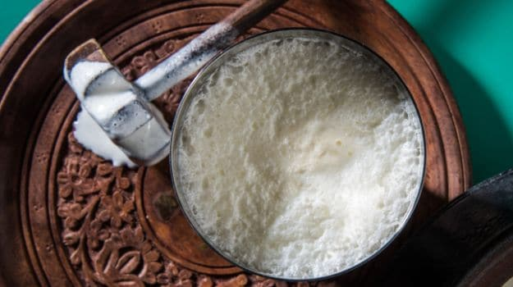Best punjabi dishes: Despite being the land of five rivers, you won't find much seafood on the menu

Since the state boasts of being one of the largest consumers of milk, you will never sit down to eat in [Punjab](https://www.ndtv.com/food/lohri-2019-date-significance-celebration-and-festive-foods-of-this-harvest-festival-1974621) without a glass of *[lassi](https://food.ndtv.com/topic/lassi" \t "_blank)*or *[chaach](https://food.ndtv.com/ingredient/buttermilk-700965" \t "_blank)* by your side. Moreover, being a wheat producing area, Punjabis are known for experimenting with breads. [*naan*](https://food.ndtv.com/recipe-naan-98842), *[rumali roti](https://food.ndtv.com/recipe-roomali-roti-99102" \t "_blank)*, [*kulchas*](https://food.ndtv.com/recipe-kulcha-98865)(stuffed bread) and parathas are some of the popular bread varieties here.

People in Punjab are also passionate about cooking with *[ghee](https://food.ndtv.com/ingredient/clarified-butter-700996" \t "_blank)*and [butter](https://food.ndtv.com/ingredient/butter-700964). Most star curries are cooked in 'desi ghee' and breads to go with them are served 'makhan mar ke'. Spices are like *[garam masala](https://food.ndtv.com/ingredient/garam-masala-701043" \t "_blank)*, [coriander powder](https://food.ndtv.com/ingredient/coriander-powder-701217), [cumin](https://food.ndtv.com/ingredient/cumin-seeds-701017) and [carom seeds](https://food.ndtv.com/ingredient/carom-seeds-700892) are used generously.  The key is to perfectly balance the different flavours, so that no single flavour becomes overwhelming.

## Learn from our specialist chefs and lay out an elaborate spread as we bring you 13 classic recipes straight from a Punjabi kitchen.

### ****1.****[Butter Chicken](https://food.ndtv.com/recipe-butter-chicken-106717)

Presenting, the classic butter chicken that is unknown to none. Juicy chicken pieces bathed in a creamy gravy bursting with authentic flavours.

Best punjabi dishes: Presenting, the classic butter chicken that is unknown to none

### ****2.****[****Sarson Ka Saag Aur Makki Ki****Roti](https://food.ndtv.com/recipe-sarson-ka-saag-aur-makki-ki-roti-218092)

Palak, bathua and sarso saag come together to create a sensation with hearty makke ki roti. Simple, savoury and full of rustic flavours.

Best punjabi dishes: Palak, bathua and sarso saag come together to create a sensation with hearty makke ki roti

### ****3.****[Tandoori Chicken](https://food.ndtv.com/recipe-tandoori-chicken-232839)

Hard to resist, tandoori food never fails to please one and all. Chef Aditya Bal shows you simple steps and tricks to create some tandoori magic right in the comfort of your home!

Best punjabi dishes: Hard to resist, tandoori food never fails to please one and all

### ****4.****[Chole Bhature](https://food.ndtv.com/recipe-chole-bhature-231327)

Talk about Punjabi food and the popular chole bhature can never be given a skip. The dish has become one of the favourites with people across the country and is also one of the must try Indian delicacies.

Best punjabi dishes: Talk about Punjabi food and the popular chole bhature can never be given a skip

### ****5.****[Masala Channa](https://food.ndtv.com/recipe-masala-channa-346952)

Boiled chickpeas wrapped in a flavourful mix of masalas and cooked to perfection. A quick fix for an afternoon meal or a great option for a hurried weekday dinner. This recipe will be loved by one and all.

Best Punjabi dishes: Boiled chickpeas wrapped in a flavourful mix of masalas and cooked to perfection

### ****6.****[Dal Makhani](https://food.ndtv.com/recipe-dal-makhani-98968)

From the local highway dhabas to some of the most sophisticated five star hotels - Dal makhni finds its dedicated space on menus across eating joints and restaurants and beyond all cultural division. Master the art of cooking the queen of all dal preparations.

Best Punjabi dishes: Dal makhni finds its dedicated space on menus across eating joints and restaurants

### ****7.****[Machchli Amritsari](https://food.ndtv.com/recipe-machchli-amritsari-218211" \t "_blank)

A treat for all fish lovers. Beautiful pieces of fish, coated in a spicy batter and deep fried to a golden perfection. Garnished with a sprinkling of [garam masala](https://food.ndtv.com/recipe-garam-masala-218599) and a dash of lemon juice for that extra zing.

Best Punjabi dishes: Beautiful pieces of fish, coated in a spicy batter and deep fried to a golden perfection

### ****8.****[Dhaba Dal](https://food.ndtv.com/recipe-dhaba-dal-168595" \t "_blank)

Wonder why the food served by those simple, roadside dhabas is so distinctly flavourful? They make the most of local spices and rustic techniques and unadulterated recipes handed over by generations. Here's an authentic recipe of dhaba dal.

Promoted

Listen to the [latest songs](https://www.jiosaavn.com/featured/cooking-classics/3LRSE7CY4SVFo9wdEAzFBA__), only on [JioSaavn.com](https://www.jiosaavn.com/)

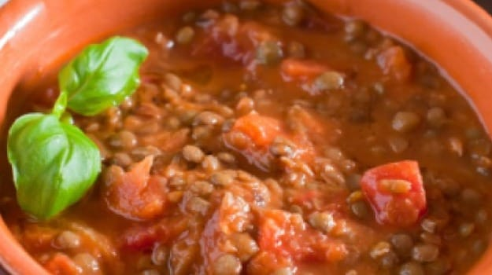Best Punjabi dishes: Who wouldn't love dhaba dal that is made with perfection

### ****9.****[Paneer Tikka](https://food.ndtv.com/recipe-paneer-tikka-233365)

For that unexpected dinner party, you can never go wrong with these quick, paneer bites. Soft and tender chunks of paneer, coated with a mix of masalas, grilled hot on skewers.

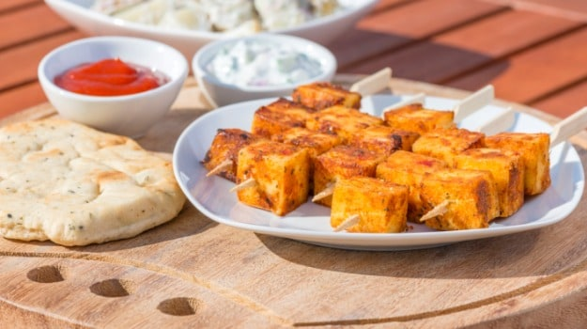Best Punjabi dishes: For that unexpected dinner party, you can never go wrong with these quick, paneer bites

### ****10.****[Murgh Malaiwala](https://food.ndtv.com/recipe-murgh-malaiwala-239459" \t "_blank)

Here's a perfect Punjabi recipe that will add stars to your dinner party. This is a no oil, no ghee recipe including chicken pieces cooked in a blend of masalas, milk and cream.

*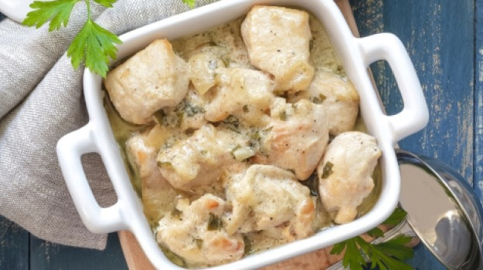*Best Punjabi dishes: Here's a perfect Punjabi recipe that will add stars to your dinner party

### ****11.****[Punjabi Kadhi Pakodi Recipe](https://food.ndtv.com/recipe-punjabi-kadhi-pakodi-952281)

A delicious creamy gravy with soft fried pakodis dipped in it, makes for an amazing Punjabi kadhi. It is made from gram flour, spices and chillies that makes for a popular lunch dish in an Indian household. Usually served with rice, it is topped with laal-mirch ka tadka.

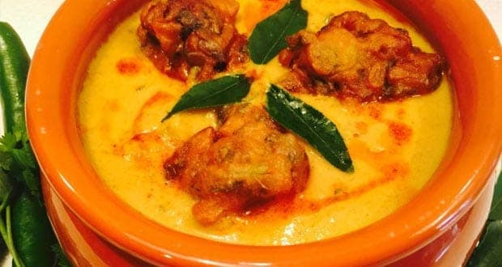Best Punjabi dishes: A delicious creamy gravy with soft fried pakodis dipped in it, makes for an amazing Punjabi kadhi

### ****12.****[Amritsari Kulcha Recipe](https://food.ndtv.com/recipe-amritsari-kulcha-701525)

Made from refined flour, potato-filling, coriander seeds, ginger, onions, et al, Amritsari kulchas are the perfect Punjabi dish that you'd want to prepare at home. This recipe has kulchas made with canola oil.

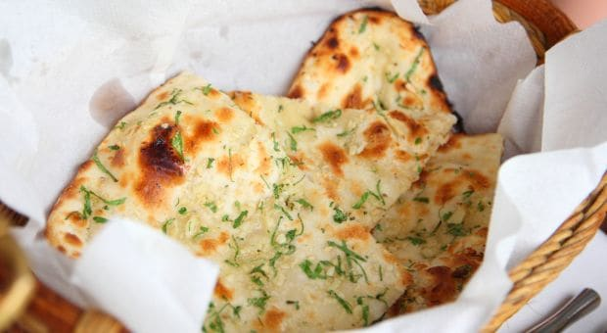Best Punjabi dishes: Amritsari kulchas are the perfect Punjabi dish that you'd want to prepare at home

### ****13.****[Bhatti da Murg Pindiwala Recipe](https://food.ndtv.com/recipe-bhatti-da-murga-pindiwala-641818)

Bhatti da murg pindiwala is a gem from the streets from Punjab where the chicken is cooked on a charcoal grill. Chicken legs are marinated overnight in fine spices and cooked to perfection. This is something that will melt-in-your-mouth and is bound to make you fall in love.

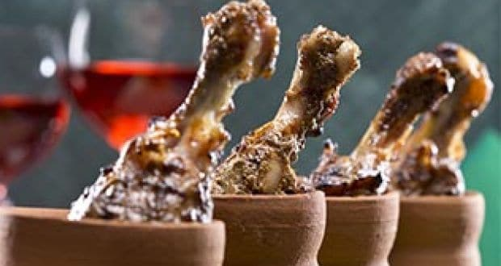Best Punjabi dishes

Famous shopping things in Punjab:

<https://lighttravelaction.com/best-punjab-souvenirs-to-pick-patiala-amritsar/>

from this site u can see

**Background images:**

